# Provincial Government

# Student Booklet

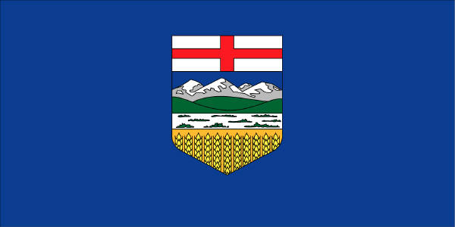

**6.1.5 analyze the structure and functions of Alberta’s provincial government by exploring and reflecting upon the following questions and issues:**

• How is the provincial government structured?

• What is the role and status of the Lieutenant Governor within the provincial government?

• What are the responsibilities of the provincial government (i.e., laws, taxes, services)?

• How are representatives chosen at the provincial level of government (i.e., electoral

process)?

• What are the differences between the responsibilities of a Member of the Legislative Assembly (MLA) and a cabinet minister?

**Key Terms**

|  |
| --- |
| Political parties  A group of people with similar ideas about how to run a province or a country |
| Independents  Candidates who do not belong to a party |
| MLA’s  Member of Legislative Assembly – elected members of the Legislative Assembly |
| Government  A person or persons ruling a country, province, district, city etc. |
| Opposition  The elected members of the political parties that d not form the government |
| Official Opposition  The party with the second-largest number of elected representatives |
| Polls  An area within a constituency |
| Premier  The leader of the political party that forms the government and who becomes the head of the government |
| Recount  What happens when the numbers are very close in an election |
| Constituency Office  An MLA’s office in his or her constituency |
| Constituents  The people who have the right to vote in a constituency |
| Lieutenant governor  The official head of a provincial government, appointed by the Governor General in Council, for a term of five years; the representative of the Crown in a province |

Constituency: An set area/region an MLA represents

**Structure of the Alberta Provincial Government**

The official government party of Alberta is the New Democrat Party (NDP). The leader of the government is Rachel Notley (premier).

The official opposition party of Alberta is the United Conservative. The leader of this party is Jason Kenney.

(p. 256)

The ____Premier________________ is the leader of the political party with the most seats in the provincial government. The ____Premier_________ is a ______member______ of the Legislative _______Assembly______, and represents the _____needs_____ of one constituency. As a leader of the government, or ______Premier_______, this person also ________represents______ Alberta.

**Inside the Legislative Assembly of Alberta**

Fill in the Picture Below from Page 246 of your text.

Media Gallery

Public Gallery

Public Gallery

Opposition MLAs

Gov’t

MLAs

Speaker

Mace

There are __87___ elected representatives in the Legislative Assembly. When a representative wins an election it gives them a right to a ___seat____ in the Assembly. Each ___seat_____ matches an area of an electoral division or _constituency_________. Constituencies are defined by ____population_____, or natural divides, such as __mountains_________ or ____rivers__________. The boundaries of Constituencies _____change_____ as the population of Alberta Changes. **(p.254-255)**

**Roles of Political parties in Provincial Government:**

|  |  |
| --- | --- |
| Party forming the Government | Party forming the Opposition |
| * Has more elected MLA’s than the other parties * Holds a specific set of ideas * Debates with opposition * Collects and spends taxes * Creates and makes changes to laws/bills | * Has fewer elected MLA’s than the govt. party * Has different ideas and goals then the party that formed the govt. * Challenges the ideas put forth by the govt. * Challenge how much the govt. collects in taxes * Debate the govt. |

**Provincial Elections (248-253)**



What are the differences between local governments and provincial governments in the nominating, and campaigning?

***Nominating***- **Provincial** – chose political party candidate in constituencies, individuals can be nominated as independents, must be knowledgeable about role of MLA , 25 signatures needed

**Local** – individuals nominated, no connection to a political party, knowledgeable about required duties for mayor, reeve, councillor, etc., 5 signatures needed

***Campaigning*** – **Provincial** – candidates supported by political party members, campaign costs supported by political party donations. Campaign literature identifies political party and candidate, must go door-to-door, attend forums and give interviews.

**Local** – candidates not supported by political party, campaign costs are not supported by political party, campaign literature is candidates choice, must go door-to-door, attend forums, give interviews

**What are the roles and responsibilities of Provincial Government? Pg. 266-269**

|  |  |  |
| --- | --- | --- |
| **Taxes** | **Bills/Laws** | **services** |

**Services of the Provincial Government (266-268)**

The Government pays for services by collecting taxes. The Provincial government collects _____income________ tax, which is a tax paid by the citizens of ______Alberta___ based on how much money they ______make_______. The government decides how to spend taxes, and use the money to provide services by creating a ____________budget___________.(p.268)

Services the provincial government provides are the responsibility of a certain ______Ministers__________. The head of this ______Ministry_________ is called a __________Cabinet__________ Minister. A MINISTRY is a part of a __________provincial government_ with a specific ______purpose_____ and staff, and run by a___Cabinet Minister________. (p. 261, 266)

**Look in the blue pages of a local phone book, on the government of Alberta website, or pg 267 of the text book to list 3 ministries, and what services they provide.**

**Steps to Pass a Law in the Legislative Assembly (269-271)**

Give an example of three laws passed by the provincial government:

|  |
| --- |
|  |
|  |
|  |

**Role of the Lieutenant Governor in the Legislative Assembly (pg. 270-272)**

**Responsibilities of MLA’s (p. 257-258)**

MLA’s stands for ________Member of Legislative Assembly_______________

The opposition MLA’s are important because the government needs someone to provide another viewpoint or perspective. The opposition is often called a “____watchdog____________”. This ensures fairness and honesty.

**Differences between MLA and Cabinet Minister**

**The Mace- A Symbol of Democracy**

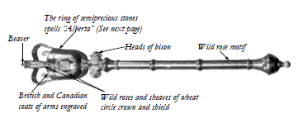

The Mace contains several symbols of Alberta. How do Albertans identify with these symbols.

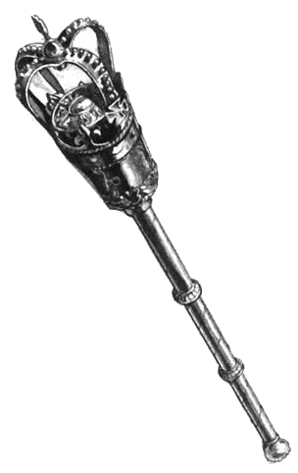

What parts of provincial government demonstrate democracy?